Session Variables for Shopping Carts

The following example uses session variables to create a simple shopping cart. You can either use this code as inspiration or as a starting point for your own shopping carts, which you can build off with additional functionality, using the exercises below.

First you will need to create a new database on your phpMyAdmin and create a table to with the different types of cheese and their prices like so:

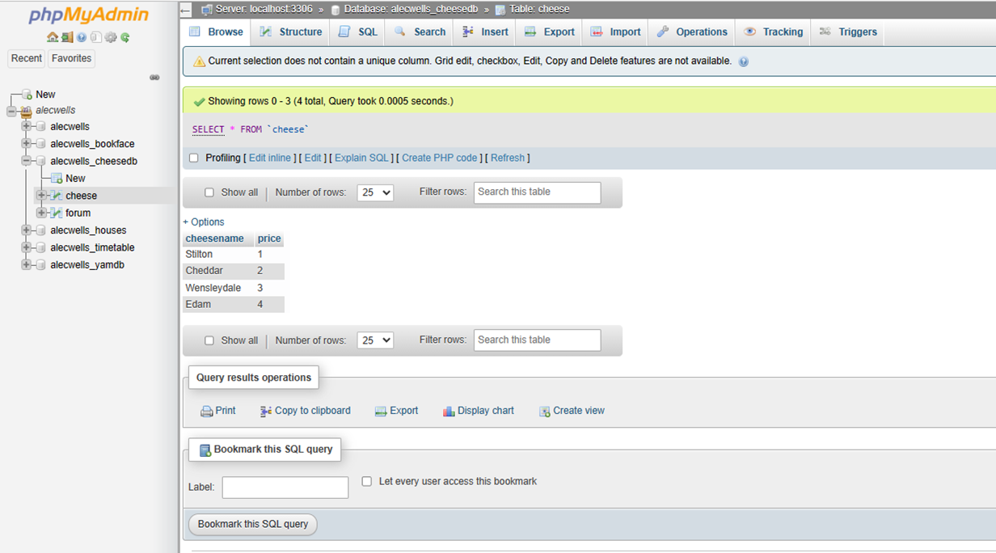

This is the stylesheet for the cheesecart example, call this ‘cheese.css’:

body {
font-family:arial;
font-size: 12pt;
background-color: #ffb97b;
}

h1 {
font-family: arial;
color: indigo;
text-align: center;
}

Next we will make a form on a HTML page for the user to select the type of cheese they wish to purchase and the amount of cheese they will add to the cart, call this file ‘cheese_cart1’:

<html>
<head>
<title>Our Cheese Emporium</title>
<link rel="stylesheet" type="text/css" href="cheese.css" />
</head>
<body>
<h1>
Welcome to the Cheese Emporium - The finest cheese site on the Web
</h1>
<p>
Choose from the finest cheeses in the whole of York St John</p>
<form class="Style2" id="cheeseform" action="cheese_cart2.php" method="post">
Select Your cheese: <select id="cheesetype" name="cheesetype">
<option value="stilton">Stilton</option>
<option value="cheddar">Cheddar</option>
<option value="wensleydale">Wensleydale</option>
<option value="edam">Edam</option>
</select>
<br />
How much do you want (lbs): <input type="text" name="amount" id="amount" />
<input type="submit" value="submit">
</form>
</body>
</html>

This next page will request the cheese type and amount from the html form, then it will correlate and request the pricing from the database for that cheese type before creating 4 session variables of the cheese type, price, amount and total cost of the order, call this file ‘cheese_cart2’:

<?php
session_start();
?>

<html>
<head>
<title>Cheese Emporium - Shopping Cart</title>
<link rel="stylesheet" type="text/css" href="cheese.css" />
</head>
<body>
<?php
$cheesename = $_REQUEST['cheesetype'];
$cheeseamount = $_REQUEST['amount'];
$conn=mysqli_connect('localhost',’username’ ,'password', ‘databasename’);
$sql="SELECT * FROM cheese where cheesename='$cheesename' ";
if (mysqli_connect_errno())
{
echo "Failed to connect to MySQL: " . mysqli_connect_error();
}
$rs=mysqli_query($conn,$sql);
if (!$rs)
{
die("Could not get data ".mysql_error());
}
if ($row=mysqli_fetch_array($rs)) { //if there is an output
$cheeseprice=$row['price'];
}

echo "You have selected ". $cheeseamount." lbs of ".$cheesename." which is priced at ".$cheeseprice." per pound <br />";
$price=$cheeseamount*$cheeseprice;
echo "The price for this cheese transaction is: £".$price."<br />";
$_SESSION["cheeseamount"] = $cheeseamount;
$_SESSION["cheesename"] = $cheesename;
$_SESSION["cheeseprice"] = $cheeseprice;
$_SESSION["totalprice"] = $_SESSION["totalprice"]+$price;
echo "Go <a href='cheese_cart3.php'>here</a> to view your shopping cart ";

mysqli_close($conn);
?>

</body>
</html>

This next page will display the contents of the cart to the user as well as the total price of the order before they confirm it, using the session variables we created earlier, call this file ‘cheese_cart3’:

<?php
session_start();
?>
<html>
<head>
<title>Cheese Emporium - Check Out</title>
<link rel="stylesheet" type="text/css" href="cheese.css" />
</head>
<body>
<h1>Your cart currently contains</h1>
<?php
echo "Cheese: ".$_SESSION["cheesename"]."<br />";
echo "Amount (lbs): ".$_SESSION['cheeseamount']."<br />";
echo "At (per lb): ".$_SESSION["cheeseprice"]."<br />";
echo "Total price: ".$_SESSION["totalprice"]."<br />";
echo "Go <a href='cheese_cart4.php'>here</a> to delete your shopping cart ";
?>
</body>
</html>

This final page will clear the shopping cart by destroying the session, and display the empty variables call this file ‘cheese_cart4’:

<?php
session_destroy();
?>
<html>
<head>
<title>Cheese Emporium - Empty Cart</title>
<link rel="stylesheet" type="text/css" href="cheese.css" />
</head>
<body>
<h1>Your cart currently contains</h1>
<?php
echo "Cheese: ".$_SESSION["cheesename"]."<br />";
echo "Amount (lbs): ".$_SESSION['cheeseamount']."<br />";
echo "At (per lb): ".$_SESSION["cheeseprice"]."<br />";
echo "Total price: ".$_SESSION["totalprice"]."<br />";
echo "Go <a href='cheese_cart1.html'>here</a> to start your new cheese experience ";
?>
</body>
</html>

Exercises:

- Create a new database on your phpMyAdmin for the 4 cheese types and give them a cost.
- Add your phpMyAdmin details to the example above, upload it to your server and then test the example.
- Modify the database on your phpMyAdmin to also have a current stock for each of the cheeses.
- Modify the example so that when they confirm the order it also subtracts the chosen amount from the current stock value.
- Modify the example to print the current stock of cheese to the user, by retrieving it from the database.
- If a cheese runs out of stock, print a message to the user saying that the item is out of stock.
- Consider adding an extra step to the example for a user to enter a delivery address using a html form.
- Add another table to your phpMyAdmin database to store all the variables of a delivery address.
- Add a PHP file that sends the delivery address to that database.

- Take the shopping cart code and modify it to work on your site.
- If you have time think about how you might make the shopping cart work with cookies instead of server variables.

